**EC2**

1. **Create a instance with instance type t2.micro for vertical scaling.**

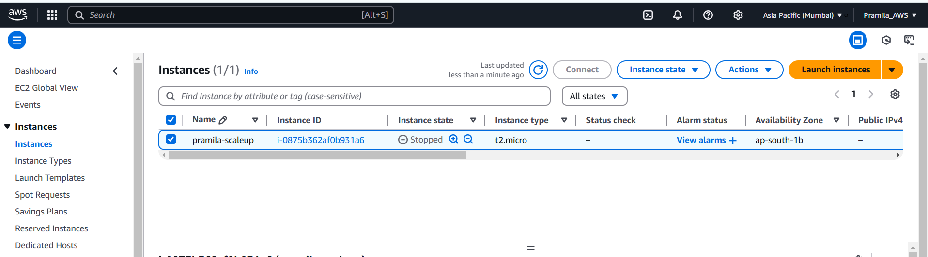

1. **Vertical scale down instance type from t2.micro to t2.nano**

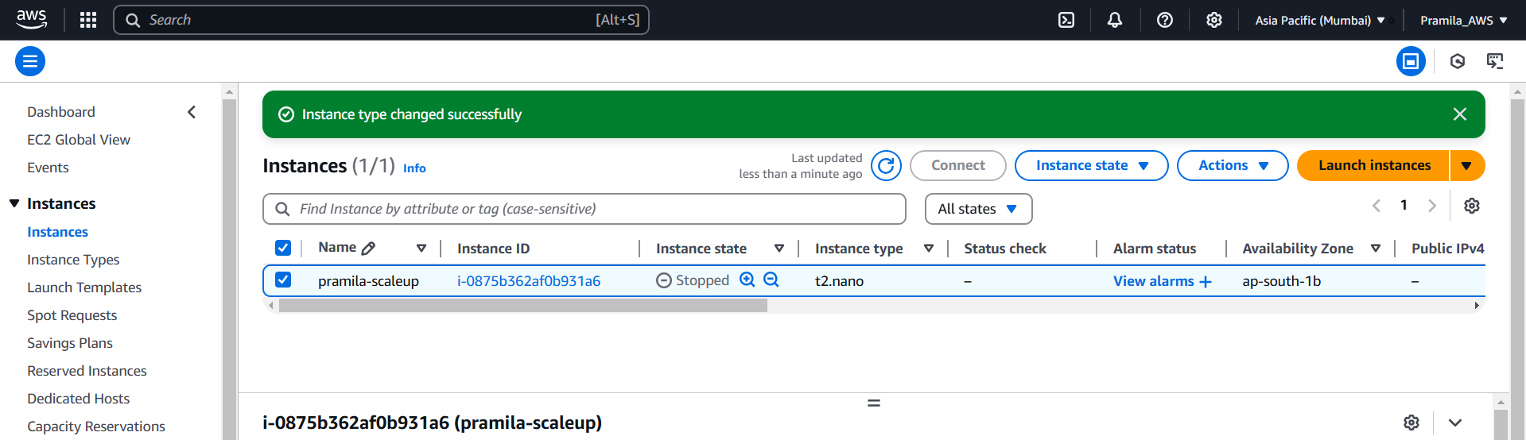

1. **Vertical scale up instance type from t2.nano to t2.micro**

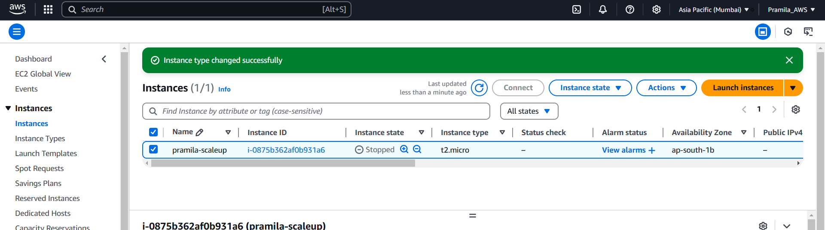

1. **Install aws cli on Ubuntu server using commands**

